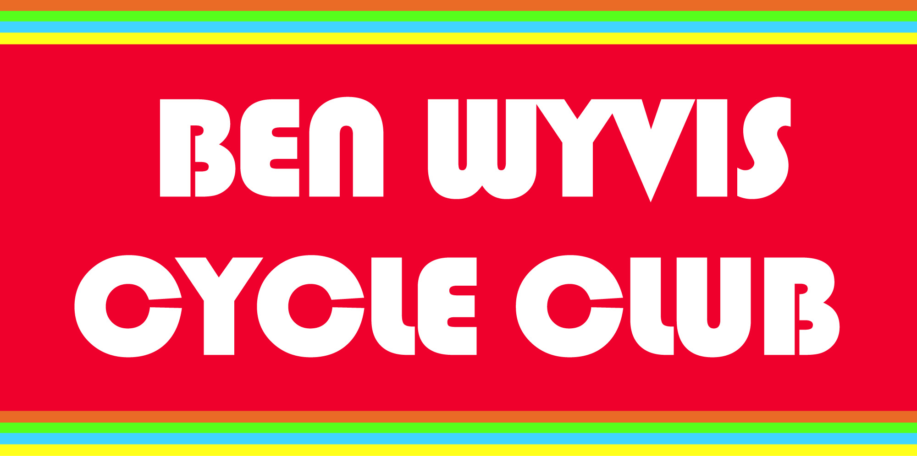

Code of Conduct for Young People

As a member of the club, you are expected to abide by the following code.
I will:
- Arrive for training and competition in good time to prepare properly
- Arrive at training and competition with a properly maintained bike
- Bring enough food and fluids to complete any cycling activity session
- Wear suitable kit (including a helmet) and clothing for all cycling activity sessions, as agreed with the coach or trail cycle leader
- Bring an inner-tube, levers & pump and/or CO2 canister & basic multi-tool for all cycling activity sessions
- Warm up and cool down properly on all occasions
- Ride within the rules and respect officials and all their decisions
- Be a good sport by applauding all good performances, whether they are made by my club or the opposition
- Control my temper – verbal abuse of officials and other riders, or deliberately distracting/ provoking an opponent is not acceptable or permitted behaviour in any sport
- Work equally hard for myself and my club – remember, the club’s performance will benefit and so will I
- Respect the rights, dignity and worth of all participants, regardless of their gender, ability, disability, cultural background or religion
- Pay any fees promptly
- Abide by the rule that junior members are not allowed to smoke, consume alcohol or take drugs of any kind other than those prescribed by a doctor and sanctioned by the club officials when taking part in club activities or representing the club
- Abide by the rule that performance enhancing drugs are not tolerated by the club
- Treat all participants in cycling as I would like to be treated – not bullying or taking unfair advantage of another participant
- Cooperate with my club coach, club mates and opponents – remember, without them there would be no competition
- Thank officials and opponents after competition.

